TABLE OF CONTENTS

1. Abstract........................................................................................................2
2. Introduction...................................................................................................3
3. Project Overview............................................................................................4
4. Sustainable Development Goal (SDG) Alignment………………………………………………5
5. SDLC Methodology…………………………………………………………………………………………………6
6. Requirements Analysis……………………………………………………………………………8
7. System Architecture Design……………………………………………………………………..9
8. User Interface Prototype Design………………………………………………………………..11
9. Project Scheduling……………………………………………………………………………………..26
10. Network Diagram……………………………………………………………………………………….28
11. GitHub Repository……………………………………………………………………………………….30
12. Testing and Evaluation…………………………………………………………………………………31
13. Conclusion………………………………………………………………………………………………..32
14. References…………………………………………………………………………………………………..33

ABSTRACT

The Sierra E-Learning System is a mobile-based educational platform designed to improve access to quality education through digital technology. The system was developed in response to the increasing need for flexible and accessible learning solutions that allow students to study regardless of their geographical location or time constraints. Through the use of mobile technology, students can access learning materials, enroll in courses, complete quizzes, monitor their academic progress, and engage in self-paced learning activities.
This project follows the Software Development Life Cycle (SDLC) methodology, specifically utilizing the Waterfall Model to ensure a structured and systematic approach to software development. The project began with requirements analysis, followed by system design, prototype development, project planning, testing, and documentation. Various tools such as Draw.io, Figma, and GitHub were used throughout the development process to design system architecture, create user interface prototypes, and manage project resources.
The Sierra E-Learning System contributes directly to Sustainable Development Goal 4 (Quality Education) by promoting inclusive, equitable, and accessible learning opportunities for students. The system demonstrates how digital solutions can bridge educational gaps and support lifelong learning. The outcome of this project is a user-friendly educational platform prototype that provides students with an effective and convenient learning environment while showcasing the practical application of software engineering principles.

INTRODUCTION

The rapid advancement of information and communication technology has transformed many sectors of society, including education. Traditional classroom-based learning, while effective, often presents challenges such as limited access to educational resources, geographical barriers, scheduling conflicts, and inadequate learning support for students in remote locations. As technology continues to evolve, educational institutions and learners increasingly rely on digital platforms to enhance learning experiences and improve access to knowledge.
E-learning systems have emerged as an important solution for addressing these challenges. They provide learners with the ability to access educational materials, complete assessments, communicate with instructors, and track academic progress through online platforms. These systems support flexible learning environments where students can study at their own pace and according to their individual needs.
The Sierra E-Learning System was developed as a mobile learning application aimed at improving educational accessibility and engagement among students. The application provides features such as user registration, authentication, course browsing, course enrollment, progress monitoring, and quiz participation. Through an intuitive and user-friendly interface, students can access educational resources from any location with internet connectivity.
The development of this project followed the Software Development Life Cycle (SDLC), ensuring a structured approach to planning, design, implementation, testing, and evaluation. By applying software engineering principles, the project demonstrates how technology can be used to solve real-world educational challenges while supporting national and global educational development goals.
Furthermore, this project aligns with Sustainable Development Goal 4 (Quality Education), which seeks to ensure inclusive and equitable quality education and promote lifelong learning opportunities for all. By leveraging mobile technology, the Sierra E-Learning System contributes toward expanding access to education and improving learning outcomes for students.

PROJECT OVERVIEW

The Sierra E-Learning System is a mobile-based educational platform designed to provide students with convenient access to learning materials and academic resources. The system serves as a centralized environment where learners can register, enroll in courses, complete educational activities, and monitor their learning progress.
The primary goal of the project is to create an accessible and efficient learning platform that encourages continuous education and self-development. Through the integration of digital technologies, the system aims to reduce barriers to education and create opportunities for learners to study independently and effectively.
The application includes several key modules such as user management, course management, assessment management, progress tracking, and profile management. These modules work together to create a comprehensive learning experience for students while maintaining simplicity and ease of use.
The project was designed with scalability in mind, allowing future enhancements such as video lessons, live virtual classrooms, discussion forums, AI-assisted tutoring, and cloud-based learning management features.

SDG 4 ALIGNMENT – QUALITY EDUCATION

Sustainable Development Goal 4 focuses on ensuring inclusive and equitable quality education and promoting lifelong learning opportunities for all. Education is widely recognized as one of the most important drivers of social and economic development. However, many students continue to face barriers that limit their access to quality educational resources.
The Sierra E-Learning System contributes to SDG 4 by providing a digital learning platform that increases educational accessibility and flexibility. Students can access learning materials regardless of their physical location, reducing geographical limitations and supporting remote learning opportunities.
The system promotes lifelong learning by encouraging students to engage in continuous education through self-paced courses and assessments. It also supports educational inclusiveness by making learning resources available through mobile devices, which are widely used by students.
In addition, the project helps improve digital literacy by encouraging learners to interact with modern educational technologies. By integrating technology into education, the Sierra E-Learning System supports the achievement of SDG 4 and demonstrates how software solutions can contribute to sustainable development and educational advancement.

SDLC METHODOLOGY
The Waterfall Model was selected for this project because it follows a structured and sequential development process.

The phases include:
1. Requirements Analysis
2. System Design
3. Development
4. Testing
5. Deployment
6. Maintenance

WATERFALL MODEL DIAGRAM:
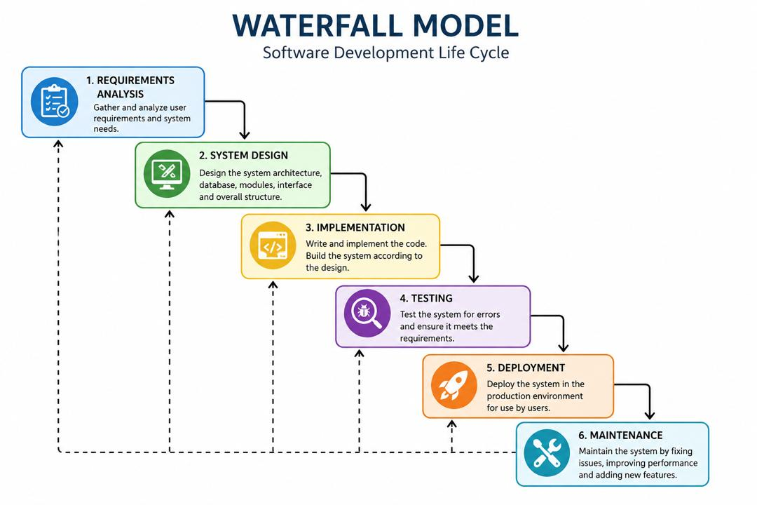

5. REQUIREMENTS ANALYSIS
The requirements analysis phase focused on identifying user needs and system functionalities.

Functional Requirements:
* User Registration
* User Login
* Course Enrollment
* Quiz Participation
* Progress Tracking
* Profile Management

Non-Functional Requirements:
* Usability
* Reliability
* Security
* Performance
* Accessibility

6. SYSTEM ARCHITECTURE DESIGN
The system architecture illustrates how different system components interact with each other.

Components include:
* User Interface Layer
* Application Layer
* Database Layer
* Authentication Module
* Course Management Module
* Assessment Module

SIERRA E-LEARNING SYSTEM ARCHITECTURE DIAGRAM

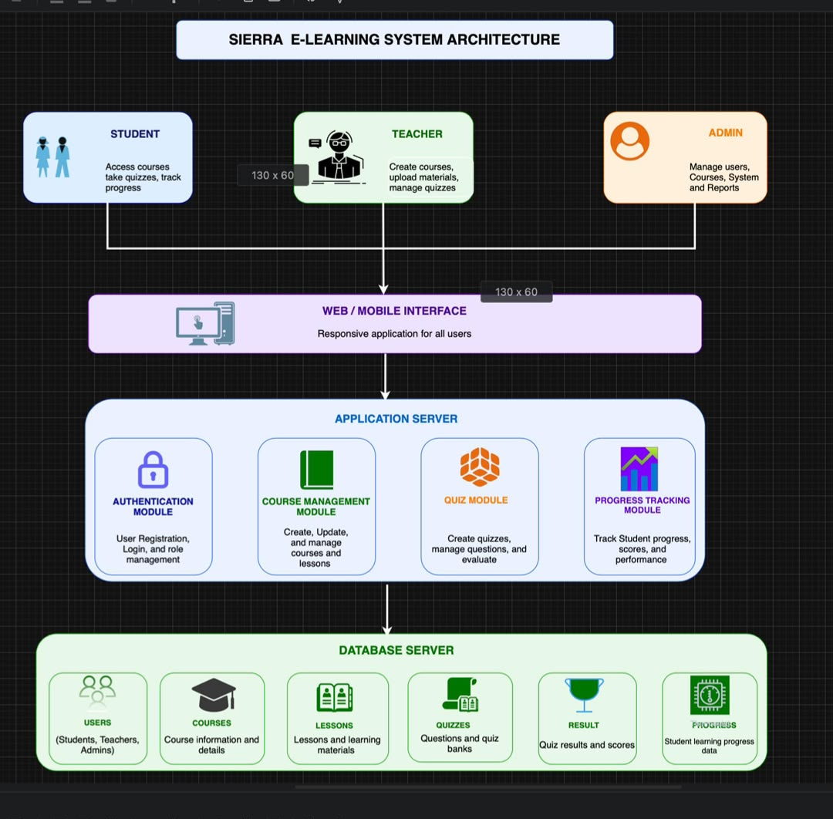

7. USER INTERFACE PROTOTYPE DESIGN
The user interface was designed using Figma to provide a user-friendly and intuitive experience.

The prototype includes:
* Splash Screen
* Login Screen
* Registration Screen
* Home Dashboard
* Course Catalogue
* Course Details Page
*Course Progress Tracking Page
*Quiz Page
* Progress Tracking Page
* User Profile Page
* Messages Page
*Sierra Ai Page
*About Sierra E-Learning &License Page

Prototype Screenshot

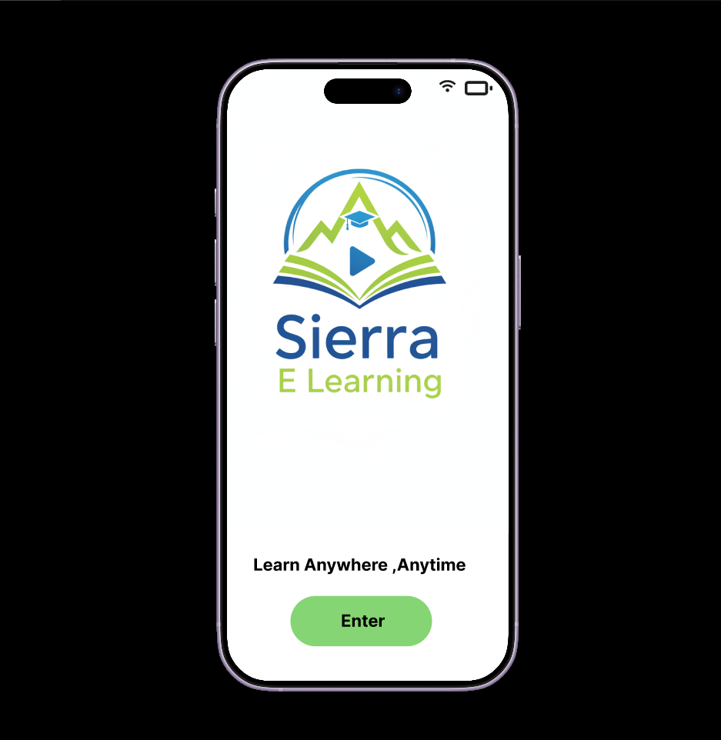
Slash Screen

Welcome Page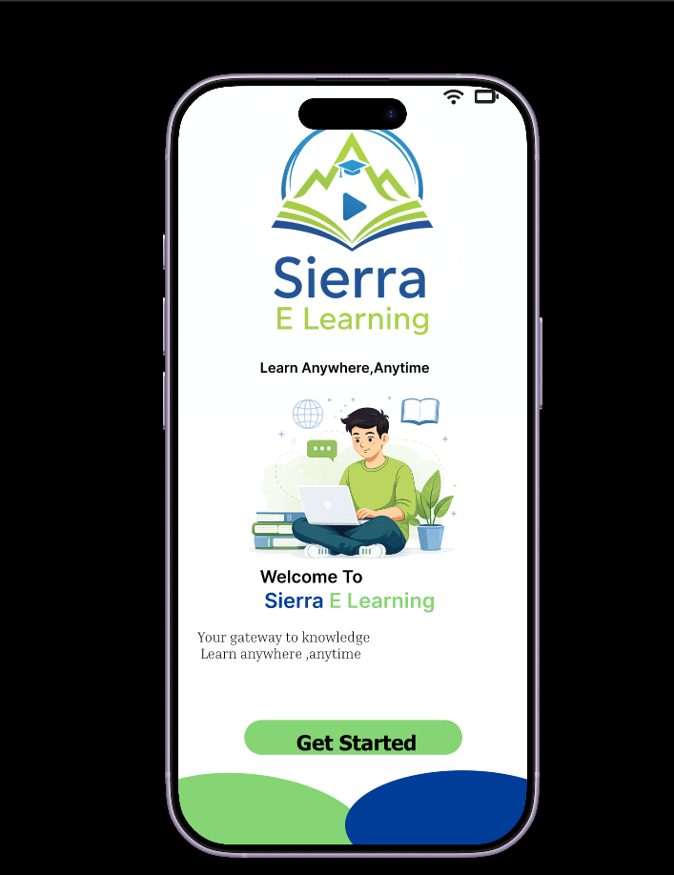
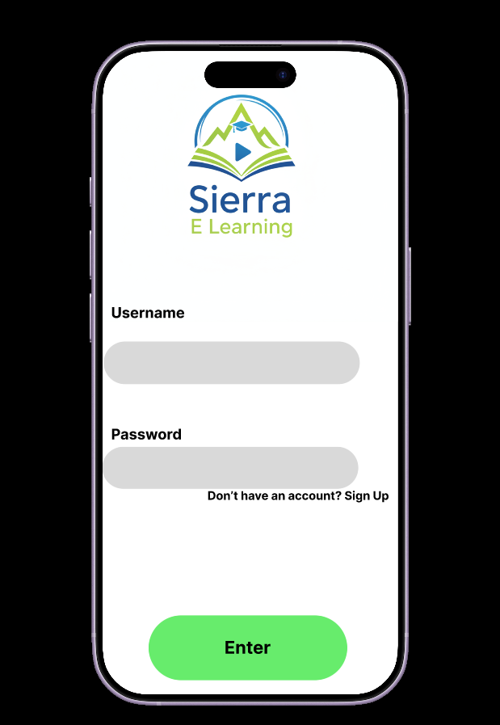

Login Page
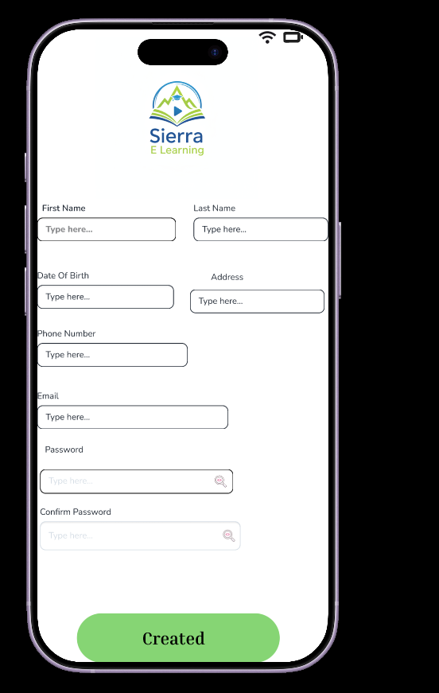
Sign Up Page
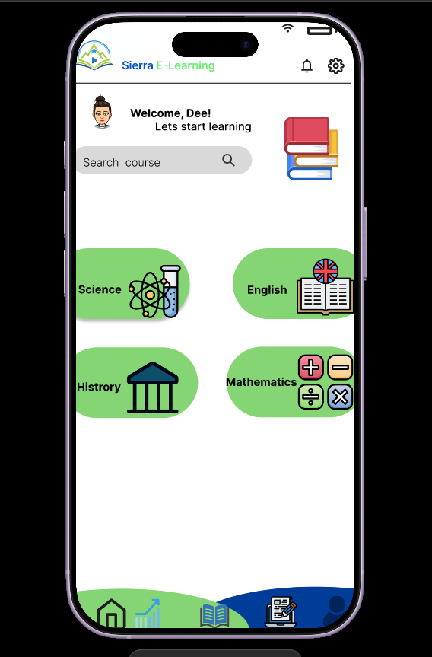
Home Page
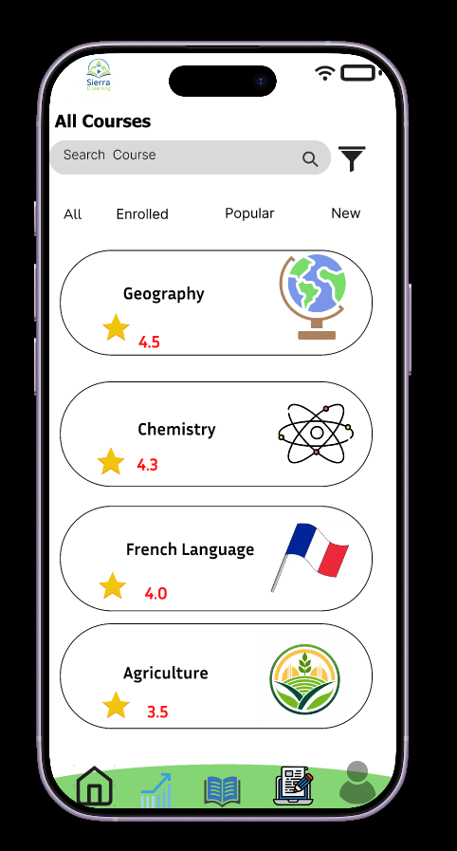
* Course Catalogue

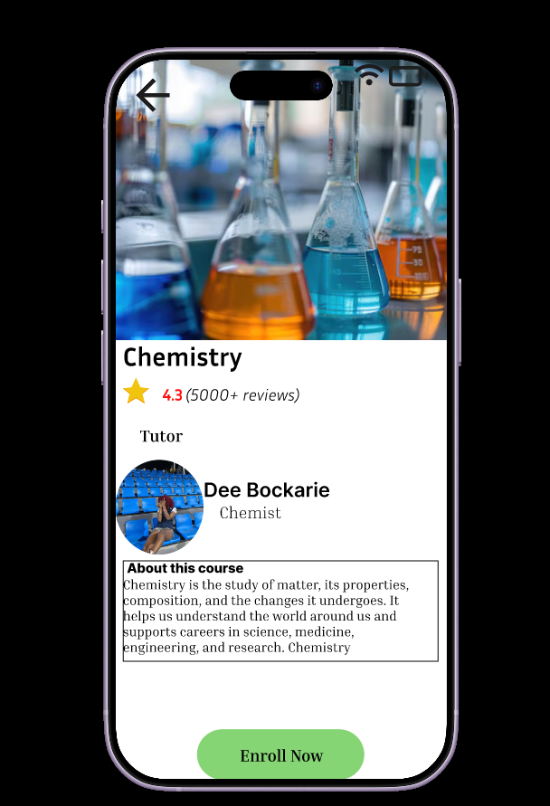
* Course Details Page

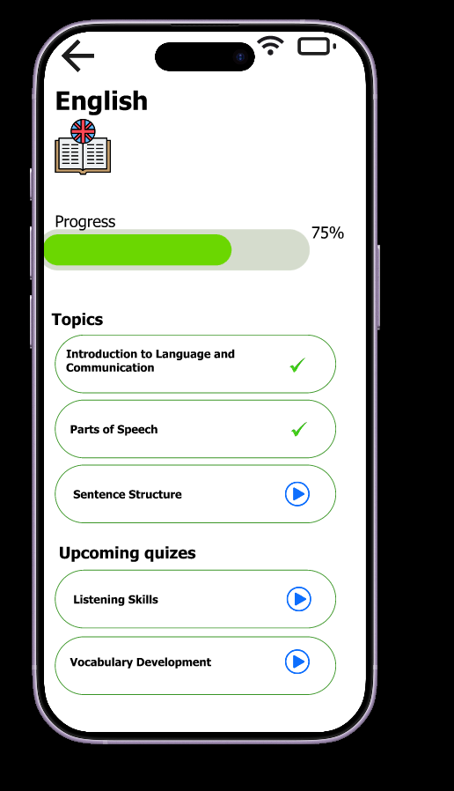
Course Progress Tracking Page

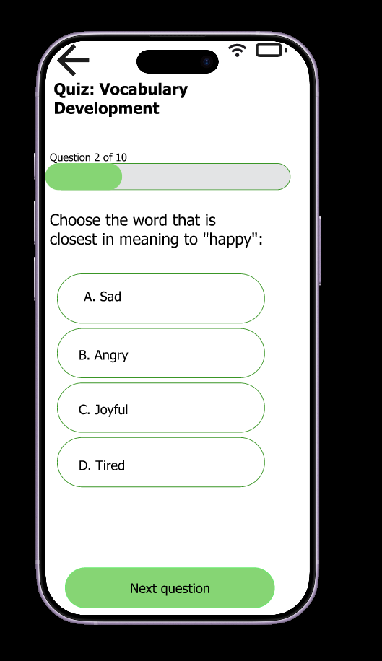
Quiz Page

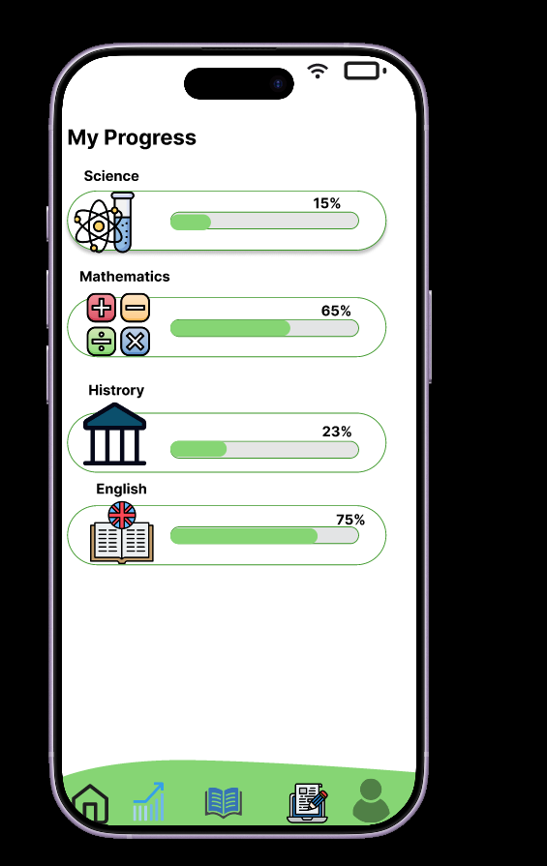
Progress Tracking Page

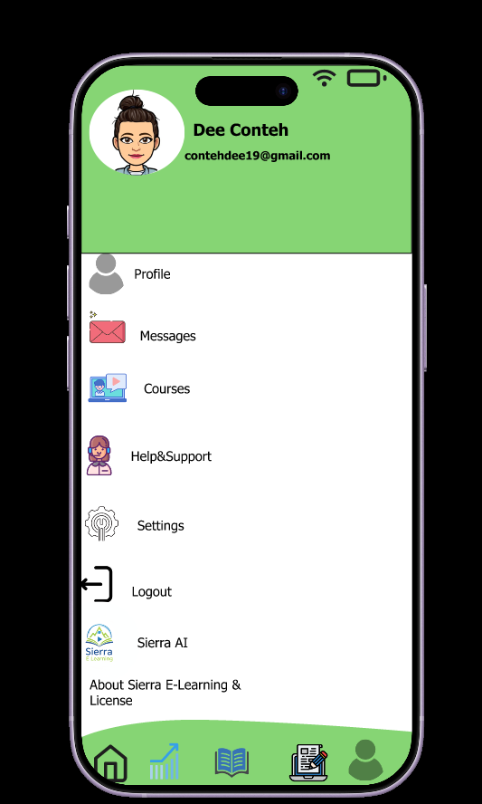
User Page

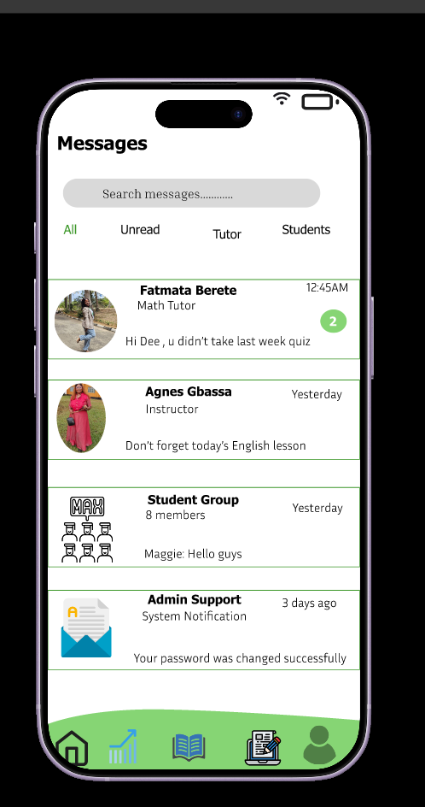
Messages Page

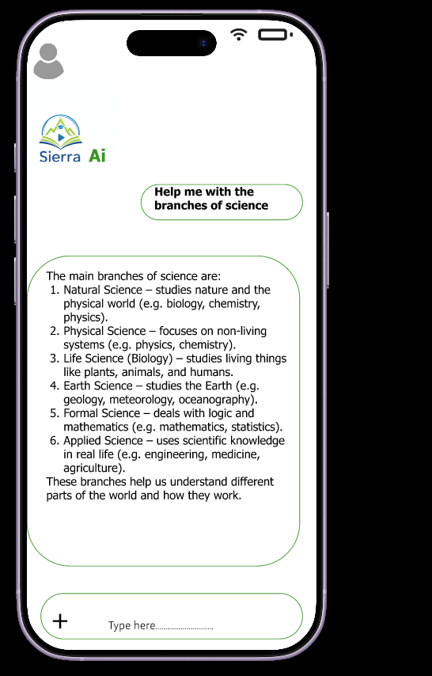
Sierra Ai Page

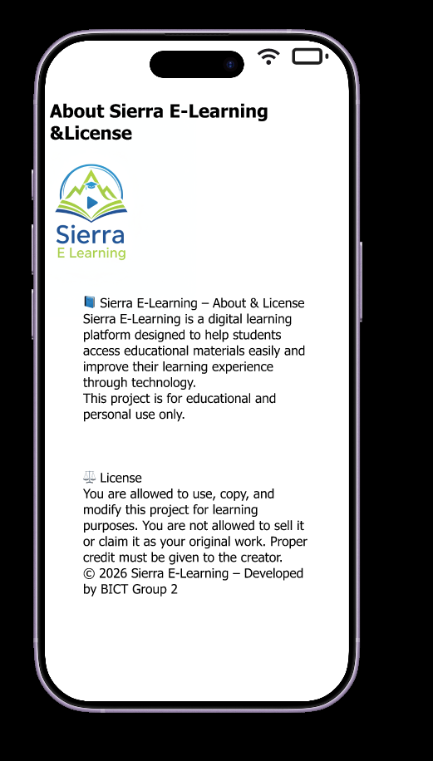
About Sierra E-Learning &License Page

8. PROJECT SCHEDULING
A Gantt Chart was developed to organize project activities and timelines.

Activities included:
* Requirements Analysis
* System Design
* Architecture Development
* Figma Prototype Creation
* GitHub Setup
* Testing and Review
* Documentation
* Final Submission

GANTT CHART IMAGE
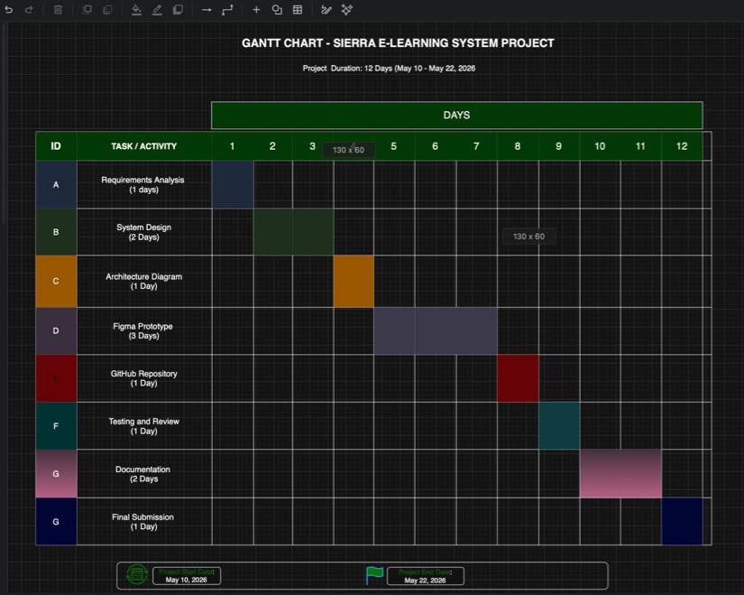

9. NETWORK DIAGRAM
A network diagram was created to show the sequence and dependency of project activities.

Activities:
A – Requirements Analysis
B – System Design
C – Architecture Diagram
D – Figma Prototype
E – GitHub Repository Setup
F – Testing and Review
G – Documentation
H – Final Submission

NETWORK DIAGRAM - SIERRA E -LEARNING SYSTEM
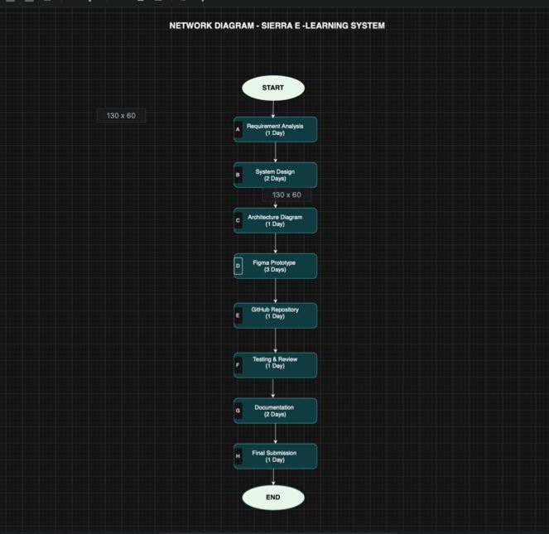

10. GITHUB REPOSITORY
GitHub was used as a version control platform for managing project files and maintaining project history.

Benefits include:
* Version Control
* Collaboration
* Backup and Recovery
* Project Tracking
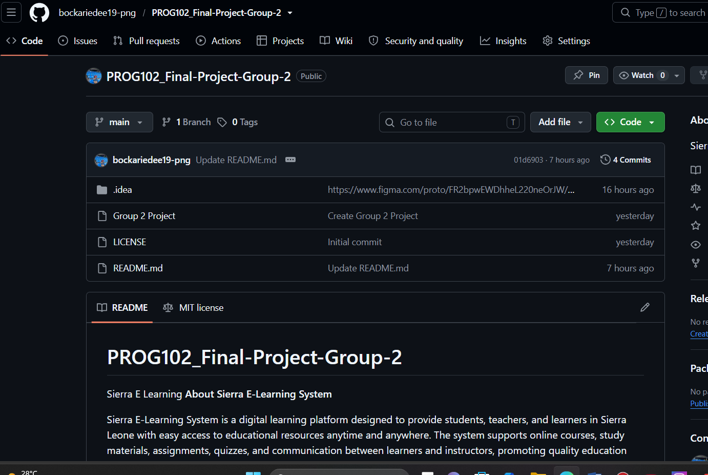

11. TESTING AND EVALUATION
Testing was conducted to verify that system features operate as expected.

Test Cases:
FEATURE | EXPECTED RESULT | STATUS
User Registration | Amount Created Successfully | pass
User Login | User Authenticated | pass
Course enrolment | Course added successfully | Pass
Quiz submissions | Answers submitted successfully | pass
Progress Tracking | Progress displayed correctly | pass

The results indicate that the system meets the specified requirements.

CONCLUSION
The Sierra E-Learning System successfully demonstrates the application of Software Development Life Cycle principles in developing an educational technology solution. The project supports Sustainable Development Goal 4 by improving access to quality education through digital learning tools.
The developed prototype provides essential functionalities such as course enrollment, quizzes, and progress monitoring. Future enhancements may include video lessons, live virtual classrooms, and AI-powered learning recommendations.

REFERENCES
United Nations Sustainable Development Goals (SDG 4)
Software Engineering Principles and Practices
Figma Design Documentation
GitHub Documentation
Draw.io Documentation

